POGIL-ish: Orbits

Read this: The hypothesis that the orbits of the planets were perfectly circular, although not grounded in reason but in the notion of a mathematically perfect universe of supernatural origins, was not that removed from fact; Earth’s orbit is 97% circular. However, all the planetary orbits are slightly off-circle, or elliptical, with the sun at one of two focal points (foci).

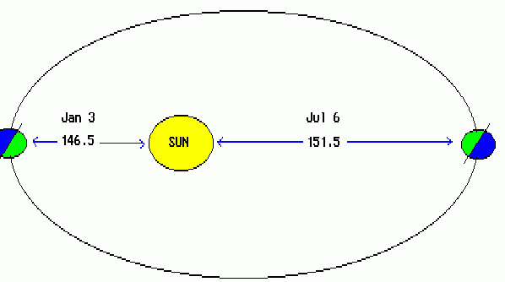
Model 1: Earths orbit
not to scale
minor axis

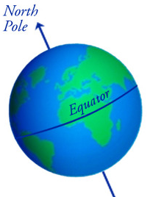

January 147.1 152.1 major axis July
PERIHELION million km million km APHELION

- Along how many axes can you bisect Earth’s orbit and create two mirror images?

2. What is the name of the shorter of the axes?

3. What is the name of the longer axis of the ellipse?

4. The two focal points are equidistant from the orbit along the major axis. The Sun is at one of the ellipses focal points. Is there anything at the second focus?

5. What time of year in the northern hemisphere is the sun closest to the Earth? What is this point in Earth’s orbit called?

6. What time of year in the northern hemisphere is the sun the furthest from the Earth? What is this point in Earth’s orbit called?

7. Since the distance between the Sun and Earth is slightly different each day, scientists instead
use the value of the semi-major axis as an ‘average’ distance between the Sun and Earth.

- What does semi- mean?

- Determine the length of the semi-major axis/mean distance to the Sun in km.

c. Restate the distance in scientific notation. (use your formula sheet!)

d. Convert the distance from km to miles (use dimensional analysis, also on the formula sheet)

Read this: How elliptical, or eccentric, Earth’s orbit is can be determined from this distance data as well. Eccentricity is the distance between the foci divided by the length of the major axis. You can use the aphelion (a) and perihelion (p) distances to find both equation variables:

eccentricity = distance between the foci/major axis which can be found using ecc = (a – p)/(a+p)

8. Determine the eccentricity of Earths orbit.

Read this: Astronomical distances often are too great for kilometers to be a useful unit; even scientific notation is unwieldy. Instead, for near solar system distances, astronomers created the Astronomical Unit (AU). The unit is defines the average distance from the Earth to the Sun (~150 million km) as 1AU. Furthermore, in his third law, Kepler determined that the average distance to the sun in AU can be used to solve for a planets orbital period, the length of time of a complete revolution about the sun.

9. Find Earth’s orbital period using its average distance in AU via the formula

Distance³ = Orbital Period²
(in AU) (in years)

10. from Model 1, determine the time of year when the Earth is closest to the Sun. Is summer the result of the Earth being at its closest point in its orbit to the sun?

Read this: Newton's Cannon was a "thought experiment" where Newton imagined that if one stood at the top of a mountain (beyond the atmosphere) and fired a cannon ball tangent to the earth's surface, its path would trace out a curve as it fell. A ball shot out at a low velocity (speed in a particular direction) would result in it landing not far from the base of the mountain. Using greater force to fire the canon ball would make the point of contact farther from the mountain. With enough speed the cannonball would never actually strike the earth, even though it would still be falling due to gravity, potentially trapped in orbit, or achieving escape velocity.

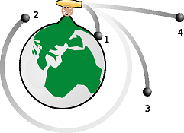
Model 2: Newtons Cannon

10. What force draws the cannonball to Earth?

11. Rank the cannonball paths by least to greatest speed.

12. Contrast the shape of the orbit formed by ball 2 with the orbit predicted for ball 3.

13. What is the effect of the greatest speed?

Read this: The effect of velocity and the gravitational force between a planet and the Sun (or the moon and Earth, etc) determine if it goes into orbit, and the shape of that orbit. Circular orbits have velocities and gravitational forces that remain constant. In elliptical orbits velocity and gravity vary, depending on the satellites proximity to the body it orbits. At shorter distances, g-force is greater and so the satellite moves faster; at longer distances the inverse is true. Arrows, called vectors, are used to show the relative magnitude of velocity and gravity in an orbit. The path the satellite follows, and its speed, reflects the interaction of these two forces.

Model 3: Vectors

gravitational force velocity

diagram a

diagram b

diagram c

14. What is the motion of a planet where the graviational force is equal to and opposed to the planets velocity ? Which diagram depicts this?

15. What is the effect on an orbiting planets speed when g-force is greater than the velocity of the planet? Which diagram depicts this?

16. What is the effect on a planets speed in its orbit when g-force is in the same direction as the planets velocity? Which diagram depicts this?

17. What does the length of an vector arrow signify?

Model 4: Orbits
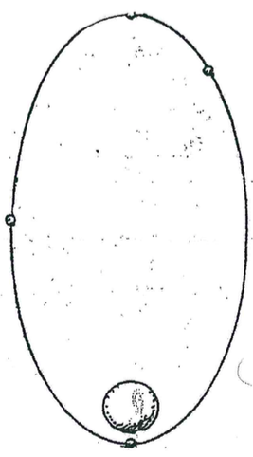
Diagram A a Diagram B e
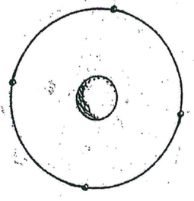
velocity

h

gravity
b
velocity
f f
gravity d

c

g
18. What is the shape of the orbit in Diagam A?

19. In a circular orbit the distance between the planet and moon is constant. How is that reflected in the magnitude of the v and g arrows at each point in the orbit in Diagram A?

20. How is the orbit in diagram B different than in diagram A?

21. How do the v and f arrows in Diagram B compare to those in Diagram A? What does this tell you about the gravitational force and velocity in an elliptical orbit?

22. What is true about the angle betten the two vectors at all points on the orbit in Diagram A? Is the same true for Diagram B?

23. At which location(s) in the B orbit are the arrow vectors combining forces – i.e. pulling in the same direction - to some degree? Is the angle between them greater or less than 90 degrees? Predict the effect of this interaction on the satellite speed.

24. At which location in the B orbit are the vectors counteracting one another - pulling the moon in opposite directions - to some degree? Is the angle between them greater or less than 90 degrees? Predict the effect of this interaction on satellite speed.

