POGILish: Characteristics of Stars

Read this: Stars are quite varied: they range from small to large, cool to hot, dim to bright, and short to long lived. The variable all are dependent on is stellar mass: how much hydrogen fuel the star is has to fuel the fusion reaction.

Model 1 : Star Stats

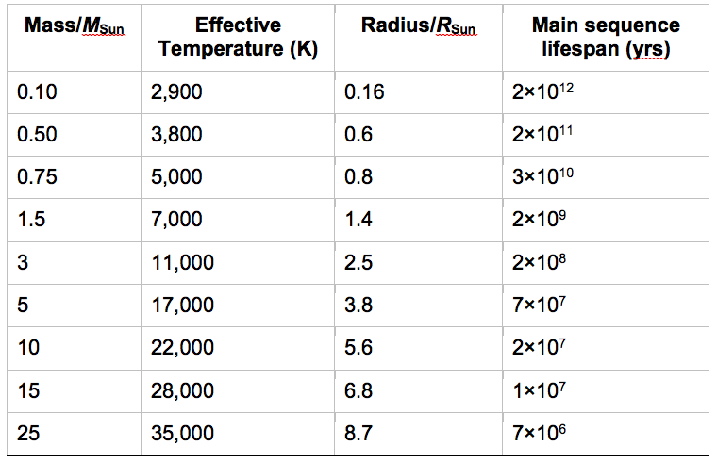

1. Make a claim about the relationship between stellar mass, and temperature. Highlight two lines of evidence in the table that illustrate the pattern.

2. Make a claim about the relationship between stellar mass and lifespan. Highlight two lines of evidence in the table that illustrate the pattern.

3. Propose reasoning that explains both patterns.

4. Complete the blank graph in Model 1. Label the X and both Y axes; sketch the trendline for each of the relationships. (Do not take the time try to fit the exact data to the graph.)

Read This: Nearly every star that we can see with the unaided eye is larger and brighter – more luminous - than our sun. This is because other stars are so distant. The star currently closest to Earth, Proxima Centauri, is 4.22 light years (40+ billion km) away! A star’s luminosity depends on its radius and surface temperature. A star with the same surface temperature as the sun, but a larger radius will be more luminous. Luminosity is even greater when the surface temperature is greater than the suns. We can calculate a star’s luminosity (L) relative to the sun’s using radius (r) and surface temperature (t, in suns) using the following formula: L = (t⁴)(r²). Convert the temperature from the table to sun units by dividing the effective temperature in Kelvin by the suns temperature, 5800K.
5. Use the data in Model 1 to calculate the luminosity of a star with a mass equal to 3 times the suns mass.

6. As you did in #5, calculate the luminosity of a star that is 15x the mass of the sun.

Read This: The Hertzsprung-Russell diagram classifies a stars brightness and luminosity against temperature and color. Using the H-R diagram, astronomers are able to assess what stage of stellar evolution any single star is in, as well deduce the time spent in each stage by stars in general.

Model 2 : H-R Diagram
Shade the ‘columns’ on the diagram from left to right in the colors indicated.

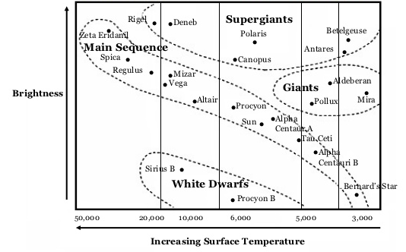
blue white yellow orange red

K

8. What type of star are most of those plotted on the H-R diagram?

a. Circle the stage of the star life cycle these are in: early mid late

b. From Model 1, infer the characteristic that accounts for the wide variation in this group.

9. The longer a stage is in a stars life, the more stars we expect to see in that stage. Infer from the H-R diagram the longest stage in the stellar life cycle.

10. What color are the hottest stars?

11. What temperature are the brightest stars?

12. Which type of radiating source is hot, yet dim?

13. What must be true for a main sequence star to be as bright as a supergiant?

14. A mid-mass star, the Sun will become a giant in a few billion years. What kinds of changes can we expect?

Read this: When we talk about a star’s brightness, we mean one of two things: how bright it actually is, (the absolute magnitude), or how bright it looks from Earth (the apparent magnitude of brightness). Both the brightness scale on the H-R diagram and the luminosity formula reflect absolute magnitude. The scale for magnitude however, is inverse; that is, a high magnitude is a low value, and vice-versa.

Model 3: The brightest stars as seen from Earth

Name | Apparent magnitude | Absolute magnitude | Distance (ly)
Sirius | -1.47 | 1.4 | 8.7
Canopus | -0.72 | -3.1 | 98
Rigil Kentaurus | -0.01 | 4.4 least bright | 4.3
Arcturus | -0.06 | -0.3 | 36
Vega | 0.04 | 0.5 | 26.5
Capella | 0.05 | -0.6 | 45
Rigel | 0.14 | -7.1 | 900
Procyon | 0.37 | 2.7 | 11.3
Betelgeuse | 0.41 | -5.6 | 520
Achernar | 0.51 | -2.3 | 118
Hadar | 0.63 least bright | -5.2 | 490

15. Which of these stars looks brightest to us?

- Which is truly the brightest?

- What variable explains the difference between absolute and apparent brightness?

16. Complete the following claim/reasoning statements using all three variables from the table:

- Although Betelgeuse has a higher ________________, it has a lower _______________ because

it is a greater _______________ from Earth.

- Rigel Kentaurus, however, has a higher ________________despite a lower ________________,

because it is less ________________.

