POGILish: Universal Gravitation

READ THIS: We experience the force of gravity on an object when we hold it up and feel its weight. Weight is a measure of the gravitational force between an object and Earth. If we were to hold that same object up while standing on the surface of Mars, however, its weight would be different. This is because the gravitational force reflects both the mass and the radius of the planet.

1. Circle one: the relationship between weight and gravitational force is:

proportionate inversely proportionate

Model 1: Surface Gravity
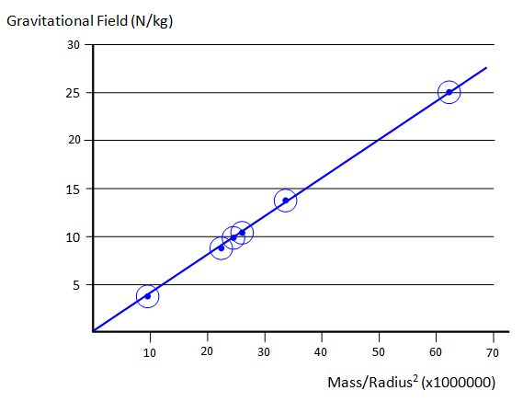

Jupiter

Neptune
Saturn, Uranus
Earth
Venus

Mercury, Mars

2. What two variables determine the gravitational force (surface gravity) of a planet?

3. Circle one: the relationship between the mass/radius ratio and force is:

proportionate (positive slope) inversely proportionate (negative slope)

4. On which planets is the gravitational force greater than on Earth?

5. Predict on which planets your weight would be lower than it is on Earth.

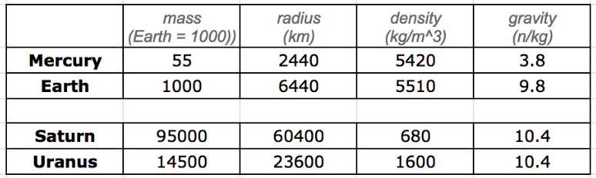

6. Mercury and Earth are both solid planets with similar densities. Use the data in the table to explain why the surface gravity is lower on Mercury than it is on Earth.

7. This relationship, however, doesn't hold up for the gas planets. Use the data in the table to explain why the gravity on Saturn and Neptune are the same.

READ THIS Newton used gravity to explain the motion of objects falling to earth (the apple!) as well as the orbits of the solar system. This insight was part of a broader understanding that gravity is a force that exists between all masses throughout the universe. In this sense, gravity is universal. As a result, no matter how far from earth you travel, the force of gravity will always connect you to home.

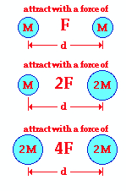
Model 2

Fig. A
- What is the independent variable that changes
in Figures A through C?

Fig. B
9. What dependent variable changes in response?

Fig. C
10. Which variable is held constant?

11. Make a claim about the nature of the relationship between mass and force.

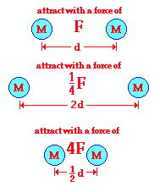
Model 3
Fig. D

12. What is the independent variable that changes
in Figures D through F?

Fig. E

13. What dependent variable changes in response?

Fig. F
14. Which variable is held constant?

15. Make a claim about the nature of the relationship between distance and force.

16. The relationships between mass, distance, and gravitational force, are summed in the equation below. Restate the equation in sentence form.

(m₁m₂)
g ~ ________
d²

17. You saw in Model 1 that the radius of a planet is variable in determining surface gravity.
Where does radius fit into the formula in question 16? Explain.

18. Rewrite the formula in question 16 as it applies to finding the surface gravity of a planet.

READ THIS Absolute magnitude of gravitational force can be calculated using the variables from the equation above, plus a constant. The Universal Gravitational Constant is written as G (not to be confused with g), and has a value equal to 6.67 x 10⁻¹¹. F stands for force, which is the force of gravity (the little g). The units are a bit complex, but the result is force, measured in Newtons (N).

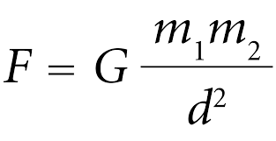
Model 4: The Universal Constant, G

19. In what ways is the formula in Model 4 different from the formula in question 16?

20. Use the formula to solve the following: determine the gravitational force between Earth (mass of 5.98 x 10²⁴ kg ) and a 70-kg Integrated Science student standing at standing at sea level, a distance of 6.38 x 10⁶ m from Earth's center.

(Hint: when numbers are multiplied, including squared, their exponents are added.
Reduce exponents in numerator with the equal number in the denominator)

21. What is the force on the student when s/he is in an airplane cruising at 40,000 feet above Earth’s surface? This would place the student a distance of 6.39 x 10⁶ m from Earth's center.

22. What is the effect of the increased altitude on the gravitational force between the planet and the student? This is an application of which of the models in this POGIL?

EXTENSION The greater the gravity force, the greater the pull on the body towards the planets center. The effect of this gravitational force is reflected in the structural adaptations of life. How might the design of vertebrate organisms, like ourselves, be designed differently had we adapted to a solid planet with a greater G-force?

Solutions:

20. The solution of the problem involves substituting known values of G (6.673 x 10-11 N m2/kg2), m1 (5.98 x 1024 kg), m2 (70 kg) and d (6.38 x 106 m) into the universal gravitation equation and solving for Fgrav. The solution is as follows:

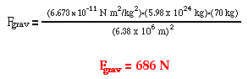

(6.673 x 5.98 x 70 x 10*)/(6.38 x 6.38) = 686. 25
* x 10 because the exponents in the numerator equal 13, and in the denominator are 12.

21. The solution of the problem involves substituting known values of G (6.673 x 10-11 N m2/kg2), m1 (5.98 x 1024 kg), m2 (70 kg) and d (6.39 x 106 m) into the universal gravitation equation and solving for Fgrav. The solution is as follows:
